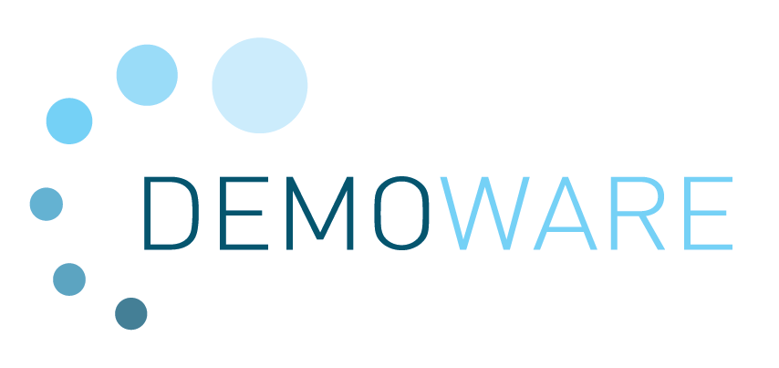

WP2
Process monitoring and performance control
Minutes of Break-out Session
Kick-off meeting 12-13 March 2014, Manresa, Spain

Attendees
CTM | Montse Calderer  Laia Llena
FHNW | Rita Hochstrat  Thomas Wintgens
UCRAN | Not attending
IRSA-CNR | Alfieri Pollice
IRTA | Robert Save
ROTEC | Noam Perlmuter
BlueBiolab | Manuel Popiol  Oliver Thronicker
DCI | Guillem Gilabert
MEKOROT | Anat Lakretz  Haim Chikurel
VERI | Not attending
IWVA | Emmanuel van Houtte
Hquimia | Angel Teno

 | Action list from WP2 break-out session
 | What | When | Who
1 | Update, completion of contact details | 01.04.14 | all
2 | Short report by involved partners  - description of methods/technology used (qPCR),  - types of flowcytometry and how it works  - Intented use in sites and envisaged timeframe | 15.04.14 | UCRAN
 |  |  | BlueBio
 |  |  | IRSA
3 | Description of non-target screening approach | 15.04.14 | VERI
4 | Description of effect-based bioassay and approaches for adapting them to compounds relevant in water reuse | 15.04.14 | BioMoni
5 | Provide schedule / scope of sampling and chemical analysis in Shafdan site | 15.04.14 | Haim  (MEKOROT)
6 | Provide description of sensor technology and potential products to be used (CTM) | 15.04.14 | CTM
7 | Prepare review structure and literature collection | 08.04.14 | FHNW
8 | Describe experimental set-up, operational plan and related monitoring strategy. | 30.04.14 | IRSA, Fiordelisi
9 | Describe methods for biofilm analysis (if already available), Outline of experimental plan related to subtask 24.1 | 30.04.14 | IRTA, CTM
Please use the “WP2 Report on background, internal planning and work progress"-file to prepare your input!

Report on WP2 break-out session
Tasks / Item discussed | Decisions / Responsibilities / due dates
Short tour of the table | Update on contact persons and details (see attached EXCEL file)
Discussion of work planned in next up to 6 months per Task
General:  The need/benefit to have transparency on methodologies, their capacity and context of application as starting point for project work is highlighted. A summary of these approaches will anyhow be part of related deliverables. | All technology provider or users in WP2 to compile technology description
Task 2.1 Monitoring and control of microbiological parameters (M1-M30)
Subtask 21.1 New techniques to assess disinfection processes (M1-M30)
Various approaches of flowcytometry for detecting will be tested by UCRAN and IRSA.
BlueBio: site involvement for activities will majorly depend on ability to ship samples (conservation issue), thus activities will focus on Braunschweig site first
Subtask 21.2 Verifying the fate of microbial contaminants in agricultural irrigation schemes (M6-30)  Which specific (new) technology will be applied here? | IRSA & Fiordelisi describe experimental set-up, operational plan and related monitoring strategy.
Task 2.2 Monitoring and control of chemical contaminants
Subtask 22.1 Establishing & improving chemical fingerprinting (M3-M30)  VERI was not represented in the meeting, no content was discussed | VERI  Description of non-target screening
Subtask 22.2 Effect-based assays for chemical contaminants detection (M3-M34)  Biomonitech is to replace Checklight in this activity. Yet BioMoni is not yet validated as SME by the Commission services. Until this issue has been settled, activities will be delayed.  More info is needed about the BMT system they operate. Monitoring could already start to verify whether effects can be detected.  Effect-based monitoring must be accompanied by chemical analysis of the tested water to be able to correlate both. | Provide schedule / scope of sampling and chemical analytic  Biomonitech / Haim
Subtask 22.3 Target compound fate (M9-M24)
Task will only start later this year. No steps discussed now.
Task 2.3 Approaches for membrane integrity testing (M1-M30)
Subtask 23.1 Survey of technologies and techniques to monitor membrane integrity (M1-M6)
A literature review will be prepared by FHNW and DCI and support of DEMOWARE sites operating membrane schemes  - Open a web-based folder; literature collection  - Proposal for report structure  - Selection of schemes for closer survey (within the project)  - Task could be complemented by a meeting/Workshop on Integrity Monitoring in Water Reuse Schemes | FHNW 1st week of April, check with Coordinator for internal area of the project website
Subtask 23.2 New concepts for membrane integrity testing (M3-M30)
Partner Nanosight has to be replaced by a suitable company (SME) with competencies in particles monitoring/counting in the sub-micron range.  One candidate has been identified, Pamas is mentioned as another option. Noam refers to a company active in this area in Israel. | Noam to send info/ link
Task 2.4 Application of electrochemical sensors for optimised distribution network operation (M1-M30)
Core technology used in this task is a sensor for biofilm formation. Sensor not yet finally selected | Provide sensor description of technology and potential products to b e used (CTM)
Subtask 24.1 Reduction of clogging in agricultural irrigation networks (M1-M24)
Dripper clogging in irrigation systems is an issue requiring corrective action. Acidification of irrigation water by acid dosing is common practice in the Mediterranean. This task will investigate the applicability of CO₂ to lower the pH. | - IRTA, CTM  - Describe methods for biofilm analysis (if already available)  - Outline of experimental plan
Subtask 24.2 Adjustable maintenance strategies in distribution networks for urban applications (M6-M30)
Objective: Observation of biofilm formation and its characterisation  - By an electrochemical sensor  - Different piping materials,  - Depending on different treatment levels  Ad a) product needs to be defined and lab-tested. Rotec has a working prototype based on ultrasound. Might be worth considering, too.  Ad b) BlueBio points out that comparative studies in drinking water networks showed that some plastics might contribute to COD in water and subsequent regrowth. Yet in treated wastewater COD from pipes might be not relevant given the residual COD.  Ad c) A test-stand for distribution network (materials, operational – flow rates) …; should be considered by CTM, to be establishe preferably on Sabadell site to allow continuous operation with real reclaimed water. | CTM - Consult literature about similar studies / set-ups
It was mentioned that subtask 24.1 is more focused on operational aspects, whilst in subtask 24.2 the health aspect for urban application may be on the forefront (in preparation for task 2.5) – regrowth of pathogens.
Task 2.5 Operational risk reduction and control through failure management (M18-M30)
Task will only start in M18. No steps discussed now.
Task 2.6 Guideline developments for process monitoring and performance control (M24-M36)
Task will only start in M24. No steps discussed now.
Other aspects discussed
Sites:  Depending on type of site (intended reuse) different water quality parameters/aspects will be relevant. E.g. the Spanish regulation has stringent limt values and monitoring requirements for Legionella for water reuse in cooling towers. Same for Salmonella in the Italian regulation (irrigation)  Opportunity to develop some monitoring devices for BlueBio?  e.g. Set-up for screening of high volumes which would enhance representative sampling  qPCR for presence of Legionella (already commercially available?) | To be discussed further on bilateral meeting with DCI and FHNW
Technologies:
Possibilities to involve in WP2 activities new technologies that have not been explicitly mentioned in the DoW.
Next meetings  Bilateral meeting FHNW and DCI on Task 2.3 in June 2014 in Tarragona.  Check options to extend to WP2 meeting at least with Spanish partners | FHNW to check with DCI and partners

